Basic Definitions and Concepts
Introduction
Welcome to the exciting world of electronics. Before we can build anything we need to look at a couple of things. Anytime you have an electrical circuit, you have voltage and electricity. We build circuits to control voltage and current.
Current
Current is what flows through a wire. Think of it as water flowing in a river. The current flows from one point to another point just like water in a river. Current flows from points of high voltage to points of low voltage. Current can be shown in circuit diagrams by using arrows as in Figure 1. The arrow shows which way the current is flowing. An I is usually included beside the arrow to indicate current.
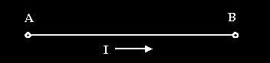
Figure 1
The unit of measurement for current is the Ampere, or Amp for short, and abbreviated as A. (The name Ampere comes from Mr. Ampere who played with electricity as a small boy in Vermont.) Common currents are 0.001 Amps (0.001A) to 0.5 Amps (0.5A). Since currents are usually small, they are usually given in the form of milliAmps (abbreviated mA.) The milli means divided by 1000, so 0.001 Amps equals 1 milliAmp (1 mA) since 1 / 1000 = 0.001. Also, 0.5 Amps equals 500 milliAmps (500mA) since 500 / 1000 = 0.5.
Voltage
Voltage indicates the power level of a point. Voltage is measured in volts. If we continue the river comparison, a point at the top of a hill would be at a high voltage level and a point at the bottom of a hill would be at a low voltage level. Then, just as water flows from a high point to a low point, current flows from a point of high voltage to a point of low voltage. If one point is at 5 volts and another point is at 0 volts then when a wire is connected between them, current will flow from the point at 5 volts to the point at 0 volts.
A measurement of voltage is much like a measurement of height. It gives you the difference in voltage between those two points. If point A is at 10 volts and point B is at 2 volts then the voltage measured between A and B is 8 volts (10 -2). This is similar to measuring height. We measure the height of hills the same way. We say the sea level is at zero feet and then compare other points to that level. On top of Mary’s Peak you are 4000 ft high (compared to sea level). In the same way we call the lowest voltage in a circuit zero volts and give it the name ground. Then all other points in the circuit are compared to that ground point. Rivers always flow towards sea level and currents always flow towards ground.
A battery is similar to a dam. On one side is a lot of stored up energy. When a path is formed from that side to the other side then current flows. If there is no path then current does not flow and the energy just stays there waiting for a path to form to the other side. The path can be a big path with lots of current flowing or a small path with just a little bit of current flowing. With a dam, a little bit of water flow could go on for a long time, but flow through a big path that lets all the water go at once would only last a short while. A battery is the same. If there is big path from the high voltage side to the low voltage side then the battery will not last long.
There are two special cases that we give names. One is when the current is zero (open circuit) and the other is when the voltage is zero (short circuit).
Open Circuit
An open circuit is when two points are not connected by anything. No current flows and nothing happens. If a wire in your vacuum cleaner breaks it can cause an open circuit and no current can flow so it does not do anything. There may be a voltage between those two points but the current can not flow with out a connection.
Short Circuit
A short circuit (or short) is when two points with different voltage levels are connected with no resistance (see resistors) between two points. This can cause a large amount of current to flow. If a short circuit happens in your house, it will usually cause a circuit breaker to break or a fuse to blow. If there is no device to limit the current, the wires may melt and cause a fire. This situation is something like a dam breaking. There is a large amount of energy suddenly free to flow from a high point to a low point with nothing to limit the current.
Series Connection
A series connection is when two components are joined together by a common leg and nothing else is connected to that point as shown in Figure 2.
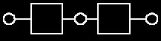
Figure 2
Parallel Connection
A parallel connection is when two components are joined together by both legs as shown in Figure 3.
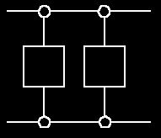
Figure 3
Basic Electrical Components
Resistors
Resistors are components that have a predetermined resistance. Resistance determines how much current will flow through a component. Resistors are used to control voltages and currents. A very high resistance allows very little current to flow. Air has very high resistance. Current almost never flows through air. (Sparks and lightning are brief displays of current flow through air. The light is created as the current burns parts of the air.) A low resistance allows a large amount of current to flow. Metals have very low resistance. That is why wires are made of metal. They allow current to flow from one point to another point without any resistance. Wires are usually covered with rubber or plastic. This keeps the wires from coming in contact with other wires and creating short circuits. High voltage power lines are covered with thick layers of plastic to make them safe, but they become very dangerous when the line breaks and the wire is exposed and is no longer separated from other things by insulation.
Resistance is given in units of ohms. (Ohms are named after Mho Ohms who played with electricity as a young boy in Germany.) Common resistor values are from 100 ohms to 100,000 ohms. Each resistor is marked with colored stripes to indicate it’s resistance. To learn how to calculate the value of a resistor by looking at the stripes on the resistor, go to Resistor Values which includes more information about resistors.

Variable Resistors
Variable resistors are also common components. They have a dial or a knob that allows you to change the resistance. This is very useful for many situations. Volume controls are variable resistors. When you change the volume you are changing the resistance which changes the current. Making the resistance higher will let less current flow so the volume goes down. Making the resistance lower will let more current flow so the volume goes up. The value of a variable resistor is given as it’s highest resistance value. For example, a 500 ohm variable resistor can have a resistance of anywhere between 0 ohms and 500 ohms. A variable resistor may also be called a potentiometer (pot for short).

Diodes
Diodes are components that allow current to flow in only one direction. They have a positive side (leg) and a negative side. When the voltage on the positive leg is higher than on the negative leg then current flows through the diode (the resistance is very low). When the voltage is lower on the positive leg than on the negative leg then the current does not flow (the resistance is very high). The negative leg of a diode is the one with the line closest to it. It is called the cathode. The postive end is called the anode.
Usually when current is flowing through a diode, the voltage on the positive leg is 0.65 volts higher than on the negative leg.
LED
Light Emitting Diodes are great for projects because they provide visual entertainment. LEDs use a special material which emits light when current flows through it. Unlike light bulbs, LEDs never burn out unless their current limit is passed. A current of 0.02 Amps (20 mA) to 0.04 Amps (40 mA) is a good range for LEDs. They have a positive leg and a negative leg just like regular diodes. To find the positive side of an LED, look for a line in the metal inside the LED. It may be difficult to see the line. This line is closest to the positive side of the LED. Another way of finding the positive side is to find a flat spot on the edge of the LED. This flat spot is on the negative side.
When current is flowing through an LED the voltage on the positive leg is about 1.4 volts higher than the voltage on the negative side. Remember that there is no resistance to limit the current so a resistor must be used in series with the LED to avoid destroying it.
To learn about LEDs through an interactive kit, look at LED and Transistor Kit
Switches
Switches are devices that create a short circuit or an open circuit depending on the position of the switch. For a light switch, ON means short circuit (current flows through the switch, lights light up and people dance.) When the switch is OFF, that means there is an open circuit (no current flows, lights go out and people settle down. This effect on people is used by some teachers to gain control of loud classes.)
When the switch is ON it looks and acts like a wire. When the switch is OFF there is no connection.

Finding the Value of a Resistor by Color Codes
To calculate the value of a resistor using the color coded stripes on the resistor, use the following procedure.
Step One: Turn the resistor so that the gold or silver stripe is at the right end of the resistor.
Step Two: Look at the color of the first two stripes on the left end. These correspond to the first two digits of the resistor value. Use the table given below to determine the first two digits.
Step Three: Look at the third stripe from the left. This corresponds to a multiplication value. Find the value using the table below.
Step Four: Multiply the two digit number from step two by the number from step three. This is the value of the resistor n ohms. The fourth stripe indicates the accuracy of the resistor. A gold stripe means the value of the resistor may vary by 5% from the value given by the stripes.
Resistor Color Codes (with gold or silver strip on right end)

Color | First Stripe | Second Stripe | Third Stripe | Fourth Stripe
Black | 0 | 0 | x1
Brown | 1 | 1 | x10
Red | 2 | 2 | x100
Orange | 3 | 3 | x1,000
Yellow | 4 | 4 | x10,000
Green | 5 | 5 | x100,000
Blue | 6 | 6 | x1,000,000
Purple | 7 | 7
Gray | 8 | 8
White | 9 | 9
Gold |  |  |  | 5%
Silver |  |  |  | 10%
Follow the above procedure with the examples below and soon you will be able to quickly determine the value of a resistor by just a glance at the color coded stripes.
Examples
Example1:
You are given a resistor whose stripes are colored from left to right as brown, black, orange, gold. Find the resistance value.
Step One: The gold stripe is on the right so go to Step Two.
Step Two: The first stripe is brown which has a value of 1. The second stripe is black which has a value of 0. Therefore the first two digits of the resistance value are 10.
Step Three: The third stripe is orange which means x 1,000.
Step Four: The value of the resistance is found as 10 x 1000 = 10,000 ohms (10 kilohms = 10 kohms).
The gold stripe means the actual value of the resistor mar vary by 5% meaning the actual value will be somewhere between 9,500 ohms and 10,500 ohms. (Since 5% of 10,000 = 0.05 x 10,000 = 500)
Example2:
You are given a resistor whose stripes are colored from left to right as orange, orange, brown, silver. Find the resistance value.
Step One: The silver stripe is on the right so go to Step Two.
Step Two: The first stripe is orange which has a value of 3. The second stripe is orange which has a value of 3. Therefore the first two digits of the resistance value are 33.
Step Three: The third stripe is brown which means x 10.
Step Four: The value of the resistance is found as 33 x 10 = 330 ohms.
The silver stripe means the actual value of the resistor mar vary by 10% meaning the actual value will be between 297 ohms and 363 ohms. (Since 10% of 330 = 0.10 x 330 = 33)
Example3:
You are given a resistor whose stripes are colored from left to right as blue, gray, red, gold. Find the resistance value.
Step One: The gold stripe is on the right so go to Step Two.
Step Two: The first stripe is blue which has a value of 6. The second stripe is gray which has a value of 8. Therefore the first two digits of the resistance value are 68.
Step Three: The third stripe is red which means x 100.
Step Four: The value of the resistance is found as 68 x 100 = 6800 ohms (6.8 kilohms = 6.8 kohms).
The gold stripe means the actual value of the resistor mar vary by 5% meaning the actual value will be somewhere between 6,460 ohms and 7,140 ohms. (Since 5% of 6,800 = 0.05 x 6,800 = 340)
Example 4:
You are given a resistor whose stripes are colored from left to right as green, brown, black, gold. Find the resistance value.
Step One: The gold stripe is on the right so go to Step Two.
Step Two: The first stripe is green which has a value of 5. The second stripe is brown which has a value of 1. Therefore the first two digits of the resistance value are 51.
Step Three: The third stripe is black which means x 1.
Step Four: The value of the resistance is found as 51 x 1 = 51 ohms.
The gold stripe means the actual value of the resistor mar vary by 5% meaning the actual value will be somewhere between 48.45 ohms and 53.55 ohms. (Since 5% of 51 = 0.05 x 51 = 2.55)
Other Resistor Information
There are some more rules that may be useful when working with resistors. You do not need to know them but if you need a resistor with a value that you do not have, you my be able to use the following information to create the value of resistor you need.
First Rule for Resistors : Series Connection
When two resistors are connected in series, as shown in Figure 1, the new resistance between points A and B is R1 + R2.
AB
Figure 1
The resistors add together. For example if R1 = 500 ohms and R2 = 250 ohms then the resistance between points A and B would be R1 + R2 = 500 + 250 = 750 ohms.
Second Rule for Resistors : Parallel Connection
When two resistors are connected in parallel, as shown in Figure 2, the new resistance is smaller than either R1 or R2. The new resistance between points A and B is (R1 x R2) / (R1 + R2).

A
B
Figure 2

For example, if R1 = 500 and R2 = 250 then the resistance between points A and B = (500 x 250) / (500 + 250) = (125,000) / (750) = 167 ohms. If R1 = R2 then the new resistance is just R1 / 2.
Using these two rules, resistors can be combined to form new resistance values.
Finding Voltage and Current Using Ohm's Law
There is a simple relationship between current, voltage and resistance. This relationship is called Ohm’s Law. The formula is the following.
Difference in Voltage = Current * Resistance
or DV = I * R
This is Form 1 of Ohm's Law.
To find current and resistance the following forms can be used. They are the same as the above formula but in a different form.
Form 2: Current = Difference in Voltage / Resistance
or I = DV / R
Form 3: Resistance = Difference in Voltage / Current
or R = DV / I
These formulas are always used for situations where there are two points with a resistor between them. DV is the difference in voltage between the two points and current is what flows between the two points. These simple relationships allow us to calculate many things. Given any two of the three values (Current, Resistance, and Difference in Voltage) the third can be found. The most common calculation is for current. Voltage is easy to measure and the resistance can be found from the resistor (see color codes). Once these values are known, current can be calculated using Form 2 of Ohm’s law, I = DV / R. For example, consider the problem shown in Figure 1. One side is at 0 volts (ground) and the other side is at 5 volts (with a multimeter, black probe on right side, red probe on left side).

Figure 1
The voltage difference between Point A and Point B is 5 - 0 = 5 volts (DV=5). There is a resistor between the two points which has a value of 500 ohms (R=500). We know that current flows from a point of high voltage to a point of low voltage so we can draw an arrow from the higher voltage to the lower voltage.
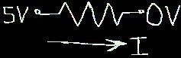
Figure 2
Now we can find the current flowing through the resistor using Form 2 of Ohm's Law.
I = DV / R
DV / R = 5 / 500
5 / 500 = 0.01 Amps
0.01 Amps = 10 milliAmps
10 milliamps can be abbreviated as 10 mA
This means the current is 10 mA. ( I = 10mA )
Now to check our answer we can use Form 1 and Form 3 of Ohm’s law. We have to use the value of current in Amps for these formulas. So if we have I = 0.01 Amps and Resistance = 500 ohms then by using Form 1 of Ohm’s law we can find:
Difference in Voltage = DV
DV = I * R
I * R = 0.01 * 500
0.01 * 500 = 5 volts
This is the voltage we started with so the value we found for the current must be right.
We can also check the answer with Form 3 by using I = 0.01 Amps and DV = 5 volts.
Resistance = R
R = DV / I
DV / I = 5 / 0.01
5 / 0.01 = 500 ohms.
So R = 500 ohms
Now consider the problem shown in Figure 3. The voltage on one side is 10 volts and the voltage on the other side is 3 volts. Therefore the voltage difference between the two points is 10 - 3 = 7 volts (DV = 7 V). The resistor is 400 ohms (R = 400).

Figure 3
Then the current flowing from left to right is
I = DV / R
DV / R = 7 / 400
7 / 400 = 0.0175 Amps
0.0175 Amps = 17.5 milliAmps
17.5 milliAmps = 17.5 mA
This means the current flowing from the left to the right is 17.5 mA.
Now suppose we have two points with a voltage difference of 5 volts. Point A is at 5 volts and Point B is at 0 volts (ground). (Notice that the voltage difference is the important part. If Point A is at 7 volts and Point B is at 2 volts then the voltage difference is the same, 7 - 2 = 5 volts.) Now suppose we want a current to flow between Points A and B and we want the current to be 0.02 Amps ( I = 0.02 Amps = 20 mA).
Now we need to find the value of the resistor so we use Form 3 of Ohm’s Law.
Resistance = Difference in Voltage / Current or R = DV / I
DV / I = 5 / 0.02 = 250 ohms
This means that putting a resistor with a value of 250 ohms between Points A and B will make a current flow from Point A to Point B and the current will be 0.02 Amps (20 mA). Now using the values of voltage and resistance, check the value of the current using Form 2 of Ohm’s law.
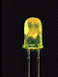Learning About Transistors and LEDs
The LED
An LED is the device shown above. Besides red, they can also be yellow, green and blue. The letters LED stand for Light Emitting Diode. If you are unfamiliar with diodes, take a moment to review the components in the Basic Components Tutorial. The important thing to remember about diodes (including LEDs) is that current can only flow in one direction.
To make an LED work, you need a voltage supply and a resistor. If you try to use an LED without a resistor, you will probably burn out the LED. The LED has very little resistance so large amounts of current will try to flow through it unless you limit the current with a resistor. If you try to use an LED without a power supply, you will be highly disappointed.
So first of all we will make our LED light up by setting up the circuit below.
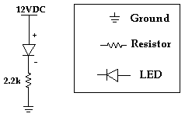
Step 1.) First you have to find the positive leg of the LED. The easiest way to do this is to look for the leg that is longer.
Step 2.) Once you know which side is positive, put the LED on your breadboard so the positive leg is in one row and the negative leg is in another row. (In the picture below the rows are vertical.)
Step 3.) Place one leg of a 2.2k ohm resistor (does not matter which leg) in the same row as the negative leg of the LED. Then place the other leg of the resistor in an empty row.
Step 4.) Unplug the power supply adapter from the power supply. Next, put the ground (black wire) end of the power supply adapter in the sideways row with the blue stripe beside it. Then put the positive (red wire) end of the power supply adapter in the sideways row with the red stripe beside it.
Step 5.) Use a short jumper wire (use red since it will be connected to the positive voltage) to go from the positive power row (the one with the red stripe beside it) to the positive leg of the LED (not in the same hole, but in the same row). Use another short jumper wire (use black) to go from the ground row to the resistor (the leg that is not connected to the LED). Refer to the picture below if necessary.
The breadboard should look like the picture shown below.
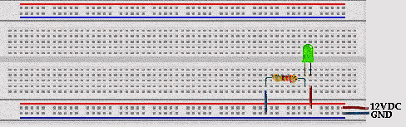
Now plug the power supply into the wall and then plug the other end into the power supply adapter and the LED should light up. Current is flowing from the positive leg of the LED through the LED to the negative leg. Try turning the LED around. It should not light up. No current can flow from the negative leg of the LED to the positive leg.
People often think that the resistor must come first in the path from positive to negative, to limit the amount of current flowing through the LED. But, the current is limited by the resistor no matter where the resistor is. Even when you first turn on the power, the current will be limited to a certain amount, and can be found using ohm’s law.
Revisiting Ohm's Law
Ohm's Law can be used with resistors to find the current flowing through a circuit. The law is I = VD/R (where I = current, VD = voltage across resistor, and R = resistance). For the circuit above we can only use Ohm's law for the resistor so we must use the fact that when the LED is on, there is a 1.4 voltage drop across it. This means that if the positive leg is connected to 12 volts, the negative leg will be at 10.6 volts. Now we know the voltage on both sides of the resistor and can use Ohm's law to calculate the current. The current is (10.6 - 0) / 2200 = 0.0048 Amperes = 4.8 mA
This is the current flowing through the path from 12V to GND. This means that 4.8 mA is flowing through the LED and the resistor. If we want to change the current flowing through the LED (changing the brightness) we can change the resistor. A smaller resistor will let more current flow and a larger resistor will let less current flow. Be careful when using smaller resistors because they will get hot.
Next, we want to be able to turn the LED on and off without changing the circuit. To do this we will learn to use another electronic component, the transistor.
1.6.1 The Transistor
Transistors are basic components in all of today's electronics. They are just simple switches that we can use to turn things on and off. Even though they are simple, they are the most important electrical component. For example, transistors are almost the only components used to build a Pentium processor. A single Pentium chip has about 3.5 million transistors. The ones in the Pentium are smaller than the ones we will use but they work the same way.
Transistors that we will use in projects look like this:
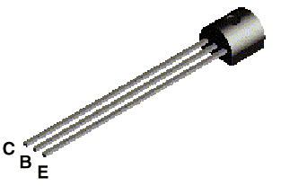
The transistor has three legs, the Collector (C), Base (B), and Emitter (E). Sometimes they are labeled on the flat side of the transistor. Transistors always have one round side and one flat side. If the round side is facing you, the Collector leg is on the left, the Base leg is in the middle, and the Emitter leg is on the right.
Transistor Symbol
The following symbol is used in circuit drawings (schematics) to represent a transistor.
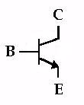
Basic Circuit
The Base (B) is the On/Off switch for the transistor. If a current is flowing to the Base, there will be a path from the Collector (C) to the Emitter (E) where current can flow (The Switch is On.) If there is no current flowing to the Base, then no current can flow from the Collector to the Emitter. (The Switch is Off.)
Below is the basic circuit we will use for all of our transistors.
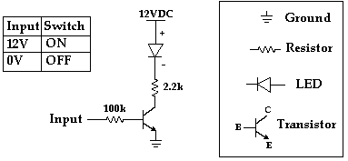
To build this circuit we only need to add the transistor and another resistor to the circuit we built above for the LED. Unplug the power supply from the power supply adapter before making any changes on the breadboard. To put the transistor in the breadboard, seperate the legs slightly and place it on the breadboard so each leg is in a different row. The collector leg should be in the same row as the leg of the resistor that is connected to ground (with the black jumper wire). Next move the jumper wire going from ground to the 2.2k ohm resistor to the Emitter of the transistor.
Next place one leg of the 100k ohm resistor in the row with the Base of the transistor and the other leg in an empty row and your breadboard should look like the picture below.
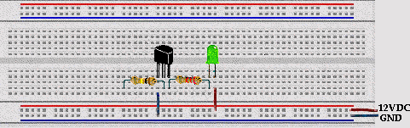
Now put one end of a yellow jumper wire in the positive row (beside the red line) and the other end in the row with the leg of the 100k ohm resistor (the end not connected to the Base). Reconnect the power supply and the transistor will come on and the LED will light up. Now move the one end of the yellow jumper wire from the positive row to the ground row (beside the blue line). As soon as you remove the yellow jumper wire from the positive power supply, there is no current flowing to the base. This makes the transistor turn off and current can not flow through the LED. As we will see later, there is very little current flowing through the 100k resistor. This is very important because it means we can control a large current in one part of the circuit (the current flowing through the LED) with only a small current from the input.
Back to Ohm's Law
We want to use Ohm's law to find the current in the path from the Input to the Base of the transistor and the current flowing through the LED. To do this we need to use two basic facts about the transistor.
1.) If the transistor is on, then the Base voltage is 0.6 volts higher than the Emitter voltage.
2.) If the transistor is on, the Collector voltage is 0.2 volts higher than the Emitter voltage.
So when the 100k resistor is connected to 12VDC, the circuit will look like this:
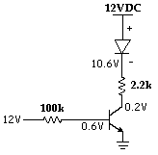
So the current flowing through the 100k resistor is (12 - 0.6) / 100000 = 0.000114 A = 0.114 mA.
The current flowing through the 2.2k ohm resistor is (10.6 - 0.2) / 2200 = 0.0047 A = 4.7 mA.
If we want more current flowing through the LED, we can use a smaller resistor (instead of 2200) and we will get more current through the LED without changing the amount of current that comes from the Input line. This means we can control things that use a lot of power (like electric motors) with cheap, low power circuits. Soon you will learn how to use a microcontroller (a simple computer). Even though the microcontroller can not supply enough current to turn lights and motors on and off, the microcontroller can turn transistors on and off and the transistors can control lots of current for lights and motors.
For Ohm’s law, also remember that when the transistor is off, no current flows through the transistor.

1.6.2 Introduction to Digital Devices - The Inverter
In digital devices there are only two values, usually referred to as 0 and 1. 1 means there is a voltage (usually 5 volts) and 0 means the voltage is 0 volts.
An inverter (also called a NOT gate) is a basic digital device found in all modern electronics. So for an inverter, as the name suggests, it's output is the opposite of the input (Output is NOT the Input). If the input is 0 then the output is 1 and if the input is 1 then the output is 0. We can summarize the operation of this device in a table.
Input | Output
1 | 0
0 | 1
To help us practice with transistors we will build an inverter. Actually we have already built an inverter. The transistor circuit we just built is an inverter circuit. To help see the inverter working, we will build a circuit with two inverters. The circuit we will use is shown below.
First Inverter (already built) Second Inverter
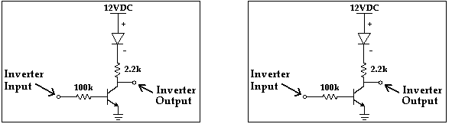
To build the circuit, use the transistor circuit we just built as the first inverter. The first inverter input is the end of the 100k ohm resistor connected to the yellow jumper wire. Build another circuit identical to the first (the basic transistor circuit from Section 1.6.1) except leave out the yellow jumper wire connected to the 100k ohm resistor (the inverter input). This circuit is the second inverter.
Connect the output of the first inverter to the input of the second inverter by putting one end of a jumper wire in the same row of holes as the 2.2k ohm resistor and the Collector of the transistor (the output of the first inverter) and putting the other end in the same row of holes as the leg of the 100k ohm resistor of the second inverter (the input to the second inverter).
Here is how to check if you built it correctly. Connect the first inverter input (the yellow jumper wire) to 12V (the positive row). The LED in the first inverter should come on and the LED in the second inverter should stay off. Then connect the first inverter input to 0V (the ground row). (You are turning off the switch of the first inverter.) The first LED should go off and the second LED should come on. If this does not happen, check to make sure no metal parts are touching. Check to make sure all the parts are connected correctly.
The input can either be connected to 12V or 0V. When the Inverter Input is 12V, the transistor in the first inverter will turn on and the LED will come on and the Inverter Output voltage will be 0.2V. The first Inverter Output is connected to the input of the second inverter. The 0.2V at the input of the second inverter is small enough that the second transistor is turned off. The circuit voltages are shown in the diagram below.
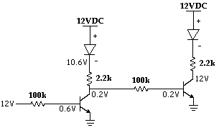
When the Inverter Input is connected to 0V, the transistor in the first inverter is turned off and the LED will get very dim. There is a small amount of current still flowing through the LED to the second inverter. The voltage at the first Inverter Output will go up, forcing the second inverter transistor to come on. When the second inverter transistor comes on, the second inverter LED will come on. To find the voltage at the output of the first inverter (10.4V), use Ohm's law. There is no current flowing through the transistor in the first inverter so the path of the current is through the first LED, through the 2.2k resistor, through the 100k resistor, through the second transistor to ground. The voltage at the negative side of the first LED is fixed at 10.6V by the LED. The voltage at the second transistor base is fixed at 0.6V by the transistor. Then given those two voltages, you should be able to find the voltage at the point in the middle (10.4V) using Ohm’s law. (Hint: First find the current and then work through Form 1 of ohm’s law to find the voltage at the point between the 2.2k resistor and the 100k resistor.)
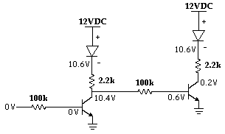
Switch the input back and forth from 0V to 12V and you can see that when the first stage is on, the second stage is off. This demonstrates the inverting action of the Inverter.
The next project in the series is called Pulses, Oscillators, Clocks...
It introduces capacitors and the LM555 timer. With these you can make circuits with LEDs that will continually flash! Click here to go to the Pulses, Oscillators, Clocks... page.
For more details on digital logic, go to Truth Table Page.
You can order the parts to build this circuit. The kit includes the parts for this project and the parts needed for the 555 project.
Beginner's Kit, $24.00 (includes shipping):
5 - 330 ohm Resistors
5 - 510 ohm Resistors
5 - 2.2K ohm Resistors
5 - 10K ohm Resistors
5 - 100K ohm Resistors
1 - 220 uF Capacitor
5 - LEDs
5 - NPN Transistors
2 - 555 Timer ICs
1 - Small Breadboard
1 - 12 Volt DC Power Supply for Breadboard
Jumper Wires
To Order, go to the Order Information Page or call 800-297-1633. If you would like a printed copy of this tutorial (as well as our other other tutorials), remember to mark that on the order form. You may also be interested in the Microcontroller Beginner Kit which includes all the parts from this kit plus several additional projects. Click here for more information.
Volume discounts and variations on the kit are also available (for example, if you already have a breadboard or power supply and don't want another). Write to support@iguanalabs.com for more information.
Oscillators, Pulse Generators, Clocks...
- Capacitors and the 555 Timer IC
.
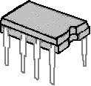
Introduction
As electronic designs get bigger, it becomes difficult to build the complete circuit. So we will use prebuilt circuits that come in packages like the one shown above. This prebuilt circuit is called an IC. IC stands for Integrated Circuit. An IC has many transistors inside it that are connected together to form a circuit. Metal pins are connected to the circuit and the circuit is stuck into a piece of plastic or ceramic so that the metal pins are sticking out of the side. These pins allow you to connect other devices to the circuit inside. We can buy simple ICs that have several inverter circuits like the one we built in the LED and Transistor tutorial or we can buy complex ICs like a Pentium Processor.
The Pulse - More than just an on/off switch
So far the circuits we have built have been stable, meaning that the output voltage stays the same. If you change the input voltage, the output voltage changes and once it changes it will stay at the same voltage level. The 555 integrated circuit (IC) is designed so that when the input changes, the output goes from 0 volts to Vcc (where Vcc is the voltage of the power supply). Then the output stays at Vcc for a certain length of time and then it goes back to 0 volts. This is a pulse. A graph of the output voltage is shown below.
.
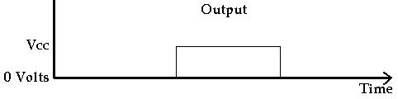
The Oscillator (A Clock) - More than just a Pulse
The pulse is nice but it only happens one time. If you want something that does something interesting forever rather than just once, you need an oscillator. An oscillator puts out an endless series of pulses. The output constantly goes from 0 volts to Vcc and back to 0 volts again. Almost all digital circuits have some type of oscillator. This stream of output pulses is often called a clock. You can count the number of pulses to tell how much time has gone by. We will see how the 555 timer can be used to generate this clock. A graph of a clock signal is shown below.
.
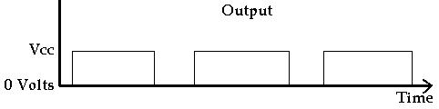
The Capacitor
If you already understand capacitors you can skip this part.
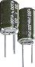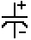
The picture above on the left shows two typical capacitors. Capacitors usually have two legs. One leg is the positive leg and the other is the negative leg. The positive leg is the one that is longer. The picture on the right is the symbol used for capacitors in circuit drawings (schematics). When you put one in a circuit, you must make sure the positive leg and the negative leg go in the right place. Capacitors do not always have a positive leg and a negative leg. The smallest capacitors in this kit do not. It does not matter which way you put them in a circuit.
A capacitor is similar to a rechargable battery in the way it works. The difference is that a capacitor can only hold a small fraction of the energy that a battery can. (Except for really big capacitors like the ones found in old TVs. These can hold a lot of charge. Even if a TV has been disconnected from the wall for a long time, these capacitors can still make lots of sparks and hurt people.) As with a rechargable battery, it takes a while for the capacitor to charge. So if we have a 12 volt supply and start charging the capacitor, it will start with 0 volts and go from 0 volts to 12 volts. Below is a graph of the voltage in the capacitor while it is charging.
.
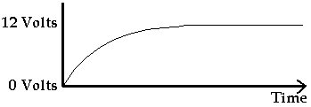
.
The same idea is true when the capacitor is discharging. If the capacitor has been charged to 12 volts and then we connect both legs to ground, the capacitor will start discharging but it will take some time for the voltage to go to 0 volts. Below is a graph of what the voltage is in the capacitor while it is discharging.
.
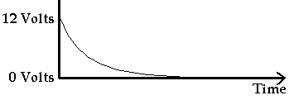
We can control the speed of the capacitor's charging and discharging using resistors.
Capacitors are given values based on how much electricity they can store. Larger capacitors can store more energy and take more time to charge and discharge. The values are given in Farads but a Farad is a really large unit of measure for common capacitors. In this kit we have 2 33pf capacitors, 2 10uf capacitors and 2 220uF capacitors. Pf means picofarad and uf means microfarad. A picofarad is 0.000000000001 Farads. So the 33pf capacitor has a value of 33 picofarads or 0.000000000033 Farads. A microfarad is 0.000001 Farads. So the 10uf capacitor is 0.00001 Farads and the 220uF capacitor is 0.000220 Farads. If you do any calculations using the value of the capacitor you have to use the Farad value rather than the picofarad or microfarad value.
Capacitors are also rated by the maximum voltage they can take. This value is always written on the larger can shaped capacitors. For example, the 220uF capacitors in this kit have a maximum voltage rating of 25 volts. If you apply more than 25 volts to them they will die. We don’t have to worry about that with this kit because our power supply can only put out 12 volts.
The 555 Timer
Creating a Pulse
The 555 is made out of simple transistors that are about the same as on / off switches. They do not have any sense of time. When you apply a voltage they turn on and when you take away the voltage they turn off. So by itself, the 555 can not create a pulse. The way the pulse is created is by using some components in a circuit attached to the 555 (see the circuit on the next page). This circuit is made of a capacitor and a resistor. We can flip a switch and start charging the capacitor. The resistor is used to control how fast the capacitor charges. The bigger the resistance, the longer it takes to charge the capacitor. The voltage in the capacitor can then be used as an input to another switch. Since the voltage starts at 0, nothing happens to the second switch. But eventually the capacitor will charge up to some point where the second switch comes on.
The way the 555 timer works is that when you flip the first switch, the Output pin goes to Vcc (the positive power supply voltage) and starts charging the capacitor. When the capacitor voltage gets to 2/3 Vcc (that is Vcc * 2/3) the second switch turns on which makes the output go to 0 volts.
The pinout for the 555 timer is shown below
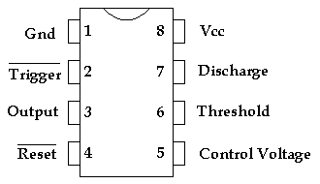
Deep Details
Pin 2 (Trigger) is the 'on' switch for the pulse. The line over the word Trigger tells us that the voltage levels are the opposite of what you would normally expect. To turn the switch on you apply 0 volts to pin 2. The technical term for this opposite behavior is 'Active Low'. It is common to see this 'Active Low' behavior for IC inputs because of the inverting nature of transistor circuits like we saw in the LED and Transistor Tutorial.
Pin 6 is the off switch for the pulse. We connect the positive side of the capacitor to this pin and the negative side of the capacitor to ground. When Pin 2 (Trigger) is at Vcc, the 555 holds Pin 7 at 0 volts (Note the inverted voltage). When Pin 2 goes to 0 volts, the 555 stops holding Pin 7 at 0 volts. Then the capacitor starts charging. The capacitor is charged through a resistor connected to Vcc. The current starts flowing into the capacitor, and the voltage in the capacitor starts to increase.
Pin 3 is the output (where the actual pulse comes out). The voltage on this pin starts at 0 volts. When 0 volts is applied to the trigger (Pin 2), the 555 puts out Vcc on Pin 3 and holds it at Vcc until Pin 6 reaches 2/3 of Vcc (that is Vcc * 2/3). Then the 555 pulls the voltage at Pin 3 to ground and you have created a pulse. (Again notice the inverting action.) The voltage on Pin 7 is also pulled to ground, connecting the capacitor to ground and discharging it.
Seeing the pulse
To see the pulse we will use an LED connected to the 555 output, Pin 3. When the output is 0 volts the LED will be off. When the output is Vcc the LED will be on.
Building the Circuit
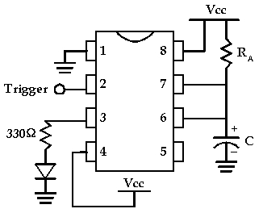
Place the 555 across the middle line of the breadboard so that 4 pins are on one side and 4 pins are on the other side. (You may need to bend the pins in a little so they will go in the holes.) Leave the power disconnected until you finish building the circuit. The diagram above shows how the pins on the 555 are numbered. You can find pin 1 by looking for the half circle in the end of the chip. Sometimes instead of a half circle, there will be a dot or shallow hole by pin 1.
Before you start building the circuit, use jumper wires to connect the red and blue power rows to the red and blue power rows on the other side of the board. Then you will be able to easily reach Vcc and Ground lines from both sides of the board. (If the wires are too short, use two wires joined together in a row of holes for the positive power (Vcc) and two wires joined together in a different row of holes for the ground.)
Connect Pin 1 to ground.
Connect Pin 8 to Vcc.
Connect Pin 4 to Vcc.
Connect the positive leg of the LED to a 330 ohm resistor and connect the negative end of the LED to ground. Connect the other leg of the 330 ohm resistor to the output, Pin 3.
Connect Pin 7 to Vcc with a 10k resistor (RA = 10K).
Connect Pin 7 to Pin 6 with a jumper wire.
Connect Pin 6 to the positive leg of the 220uF Capacitor (C = 220uF). (You will need to bend the positive (long leg) up and out some so that the negative leg can go in the breadboard.
Connect the negative leg of the capacitor to ground.
Connect a wire to Pin 2 to use as the trigger. Start with Pin 2 connected to Vcc.
Now connect the power. The LED will come on and stay on for about 2 seconds. Remove the wire connected to Pin 2 from Vcc. You should be able to trigger the 555 again by touching the wire connected to pin 2 with your finger or by connecting it to ground and removing it. (It should be about a 2 second pulse.)
Making it Oscillate
Next we will make the LED flash continually without having to trigger it. We will hook up the 555 so that it triggers itself. The way this works is that we add in a resistor between the capacitor and the discharge pin, Pin 7. Now, the capacitor will charge up (through RA and RB) and when it reaches 2/3 Vcc, Pin 3 and Pin 7 will go to ground. But the capacitor can not discharge immediately because of RB. It takes some time for the charge to drain through RB. The more resistance RB has, the longer it takes to discharge. The time it takes to discharge the capacitor will be the time the LED is off.
To trigger the 555 again, we connect Pin 6 to the trigger (Pin 2). As the capacitor is discharging, the voltage in the capacitor gets lower and lower. When it gets down to 1/3 Vcc this triggers Pin 2 causing Pin 3 to go to Vcc and the LED to come on. The 555 disconnects Pin 7 from ground, and the capacitor starts to charge up again through RA and RB.
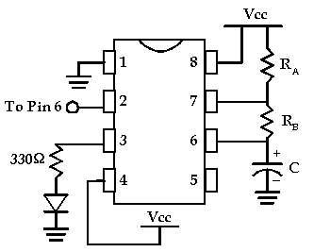

To build this circuit from the previous circuit, do the following.
Disconnect the power.
Take out the jumper wire between Pin 6 and Pin 7 and replace it with a 2.2k resistor (RB = 2.2K).
Use the jumper wire at pin 2 to connect Pin 2 to Pin 6.
Now reconnect the power and the LED should flash forever (as long as you pay your electricity bill).
Experiment with different resistor values of RA and RB to see how it changes the length of time that the LED flashes. (You are changing the amount of time that it takes for the Capacitor to charge and discharge.)
Formulas
These are the formulas we use for the 555 to control the length of the pulses.
t1 = charge time (how long the LED is on) = 0.693 * (RA + RB) * C
t2 = discharge time (how long the LED is off) = 0.693 * RB * C
T = period = t1 + t2 = 0.693 * (RA + 2*RB) * C
Frequency = 1 / T = 1.44 / ((RA + 2 * RB) * C)
t1 and t2 are the time in seconds. C is the capacitor value in Farads. 220uF = 0.000220 F. So for our circuit we have:
t1 = 0.693 * (10000 + 2200) * 0.000220 = 1.86 seconds
t2 = 0.693 * 2200 * 0.000220 = 0.335 seconds
T = 1.86 + 0.335 = 2.195 seconds
Frequency = 0.456 (cycles per second)

The 555Kit includes:
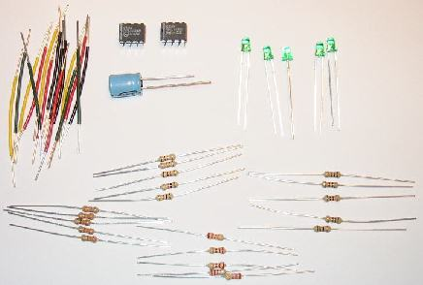
2 - 555 ICs
5 - 10K ohm Resistors
5 - 2.2K ohm Resistors
5 - 510 ohm Resistors
5 - 330 ohm Resistors
1 - 220 uF Capacitor
5 - LEDs
Jumper Wires
Building a 5 volt power supply
Most digital logic circuits and processors need a 5 volt power supply. To use these parts we need to build a regulated 5 volt source. Usually you start with an unregulated power supply ranging from 9 volts to 24 volts DC (A 9 volt power supply is included with the first kit.). To make a 5 volt power supply, we use a LM7805 voltage regulator IC (Integrated Circuit). The IC is shown below.
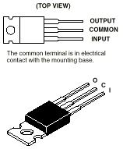
The LM7805 is simple to use. You simply connect the positive lead of your unregulated DC power supply (anything from 9VDC to 24VDC) to the Input pin, connect the negative lead to the Common pin and then when you turn on the power, you get a 5 volt supply from the Output pin. The breadboarded circuit is shown below.
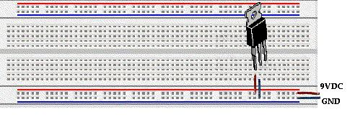
Sometimes the input supply line (the 9VDC above) may be noisy. To help smooth out this noise and get a better 5 volt output, a capacitor is usually added to the circuit, going between 9VDC and ground (GND). We use a 220 uF capacitor.
You can order the parts for this kit. It includes:
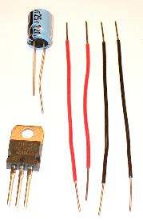
1 - LM7805
1 - 220 uF Capacitor
Jumper Wires
For Price and Ordering Information, look at 5voltKit on Order Form. If you want a printed copy of this and the other tutorials, remember to mark that on the order form.
Using the Multimeter to Measure Voltage and Resistance
Multimeters are commonly used to measure voltage and resistance between two points. Current is rarely measured because you must alter the circuit to measure the current. Since we don’t really want to alter the circuit, we measure voltage and resistance and calculate the current using Ohm’s law ( I = DV / R ).
Voltage and resistance are always measured between two points.
Voltage is the easiest and most common measurement. To measure voltage you set the multimeter to either DC or AC voltage and choose the range based on what you estimate the voltage to be. Then you touch the black (negative) probe to ground (the most negative point in the circuit) and then touch the red (positive) probe to a point in the circuit where you want to know the voltage (while keeping the black probe touching ground.) If you want to know the voltage difference (DV) between one side of a resistor and the other side you can simply put the black probe on one side and the red probe on the other. If the meter has an analog scale (a needle) and the needle goes the wrong way, reverse the red and black probes so the needle will go the other way and give you the voltage difference between those two points.
To measure resistance in a circuit, first turn off (or disconnect) the power supply. You may damage the multimeter if the circuit is still powered.) Next, select a range on the multimeter and touch two metal points in the circuit. If the needle doesn’t move or goes all the way to the end of the scale, select another range. You can not use this method to measure the resistance of a resistor in the circuit because there may be other paths between the nodes of a resistor. One leg of a resistor must be disconnected from the circuit to make sure that the only path between the two probes is through that resistor. To measure the resistance of a resistor, select the range on the meter that you think is closest to the right value and use the probes to touch either side of the resistor. If you have selected the right range, the needle will be somewhere between the left and the right end of the scale. To find the value of the resistor, read the number from the scale that matches the range you are using.
-5 & -10 Volt DC Kit
Parts needed to build a simple negative power supply
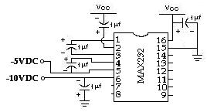
Vcc = 5 Volts DC
The schematic above shows how to build a simple -5 Volt DC and -10 Volt DC power supply using a MAX232CPE chip and a 5 volt supply. A 5 volt supply is easy to build using a common DC wall adapter (9 to 20 volts DC or so) and a 7805 chip (as in our 5 Volt Kit). The MAX232 chip is intended to be used for communicating with a PC through a serial port. (See the Data Collection Kit for more information on communicating with a PC.) A serial port requires a negative 10 volt signal to work properly so the most important thing that the MAX232 chip does is generate a -10 Volt power source for those signals. But negative voltages are also needed for other applications such as operational amplifiers (op-amps). The MAX232 chip can be used for this as long as the current requirements are not too high.
With no load, the outputs are about -5 Volts and -9.5 Volts. (The -10 Volt Source does not quite reach -10 Volts but it is still referred to as the -10 Volt Source.)
For the -10 Volt Source:
At 4 mA the voltage drops to about -8.5 volts.
At 10 mA, the voltage drops to about -6 volts.
For the -5 Volt Source:
At 3.3 mA, the voltage drops to about -4.6 volts.
At 9 mA the voltage drops to about -3.5 volts.
The graph below shows how the -10 Volt Source drops as current increases.
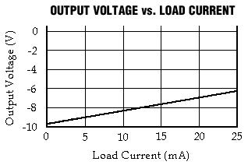
Note: The -5 Volt output and the -10 Volt output are not independent. If you are using both outputs, the voltages will drop off faster.
Since the chip can not provide much current, one common way it is used is in a double opamp configuration. The first opamp acts as a buffer, inverting the signal to a negative signal then a second opamp reinverts the signal to positive and supplies the power, drawing current from the positive voltage source, Vcc.
For more information on the MAX232 chip click here for the Data Sheet.
This kit includes:
1 - MAX232CPE
5 - 1 uF capacitors
Jumper Wires

