COME 327
LAB EXPERIMENT 1 for AXIOM BOARD

- Select a GP32 Kit for your group. You will be using the same kid from now on. You are responsible for equipments inside as well.
- Open ICS08GPGTZ In-Circuit Simulator program and select WinIDE Development Environment.
- Setup your GP32 Kits to the computers you will use. Connect the cables correctly. Your teaching assistant will help you on doing these setups.
- Run the Development Software and open the file “GP-FLASH-LED-FAST.ASM” in the path:
C:\pemicro\ics08gpgtz\GP32exampleprograms
- Construct the circuit which your teaching assistant will show you. You will use breadboards, wires, resistors and LEDs for doing it. (At the beginning you have to connect 2 Leds (to PTD4-yellow led, PTD5-red led with resistors). As shown below:
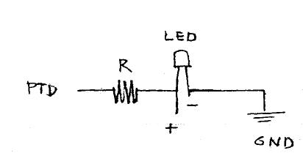
- Run the In Circuit Simulator to see the program running in real time. Examine the values in registers in each step and try to understand the behavior of the microcontroller for the code. Also examine RAM – ROM and STACK addresses in the memory map window. Use breakpoints to the program and investigate the behaviors till these breakpoints.
- Now, add a new LED (green) also to your program. That means your program should blink 3 LEDs on development board.
- Then add delays between blinking the LEDs. Your LEDs should now blink slower.
- Try to calculate the time of the delays which you added to your program. You will supply your lab report with this information.
- After finishing the experiment of this week deconstruct your circuits and kits, turn off the computer and disconnect the kits from the computer. You should deliver your kits to your teaching assistant as you get them in the beginning of the lab. There should not be any elements missing.
- You should write and deliver your lab reports till next lab session.

Required Report Format:
- Introduction
  - The aim of this experiment
  - Equipments and Components used
- Procedure
  - Explain detailed procedure you have already done
  - Give a brief explanation things you have added to your code and changes you have done
  - Draw the circuit scheme.
  - Answer the questions asked in your lab sheet.
- Conclusion

